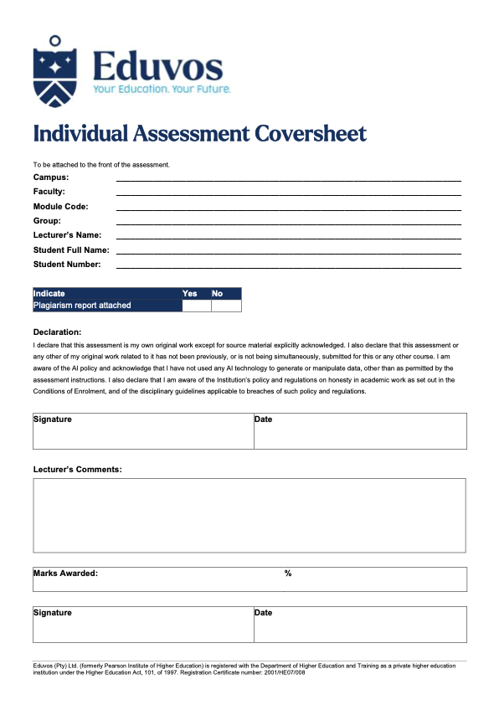
30 October 2026
BSc (Honours) Information Technology: Data Science
Online
ITNPA4-34
Tinotenda Mavetera
eduv13228736
Liam Stevens
Group 1
Table of Contents
Introduction 3
1. Question 1 3
1.1. Data cleaning 3
1.2. Feature selection 3
1.3. Baseline model 4
2. Question 2 5
2.1. Model comparison 5
2.2. Performance enhancement: class weighting 5
2.3. Deployment 6
3. Question 3 7
3.1. Building the dataframe 7
3.2. Preprocessing 7
3.3. Summary of article 1 7
3.4. Aggregate summary of articles 2-5 8
4. Question 4 9
4.1. LDA topic modelling 9
4.2. Intertopic distance map 10
4.3. GitHub repository 10
References 11

Introduction
This project applies natural language processing and machine learning to two text datasets. Natural language processing enables computers to analyse and interpret human language, supporting with tasks like text classification, summarisation, and topic modelling (Canchila et al., 2024; DeepLearning.ai, 2023).
Questions 1 and 2 use a dataset of 1,138 research abstracts labelled as either AI-related or classical research. The abstracts were cleaned and analysed to identify the relevant features, a baseline classifier was built and evaluated, and four further models were trained and compared. Class weighting was applied as a performance enhancement to address the imbalance between the two classes, and the best-performing model was deployed in a Streamlit web interface.
Questions 3 and 4 use a corpus of five research articles on research methodology. The articles were combined into a data frame and pre-processed, the first article was summarised using frequency-based extractive summarisation, and the remaining four were summarised using TextRank and aggregated. LDA topic modelling was then used to identify the main themes across the corpus, visualised with word charts, a topic heatmap and a pyLDAvis intertopic distance map.

Question 1

Data cleaning
The dataset contained 1,138 abstracts (900 classical, 238 AI) with three columns: DOI, Abstract and Label. Thirteen duplicate abstracts were removed, along with two records identified through length outliers that were not genuine abstracts ( one contained several merged abstracts, the other was a biographical essay). Each abstract was then cleaned by removing dataset-specific noise (“[Formula:see text]”, copyright notices, URLs and section headings attached to words), lowercasing, removing numbers and punctuation, lemmatising, and removing stopwords (Cuantum Technologies, 2023). This reduced the average abstract from about 172 to 101 words.

Feature selection
DOI is an identifier with missing values and no relationship to the topic, so only the abstract text was used as input, with Label as the target. TF-IDF (EMC Education Services, 2015) showed that both classes share their most common words (inflation, model, forecast), so these do not separate them. A chi-square test identified the most class-related terms as machine learning methods, such as “neural network”, “machine learning”, “LSTM” and “SVR” (Figure 1). This confirms that the abstract text is the relevant feature, with the signal coming mainly from method-related vocabulary.
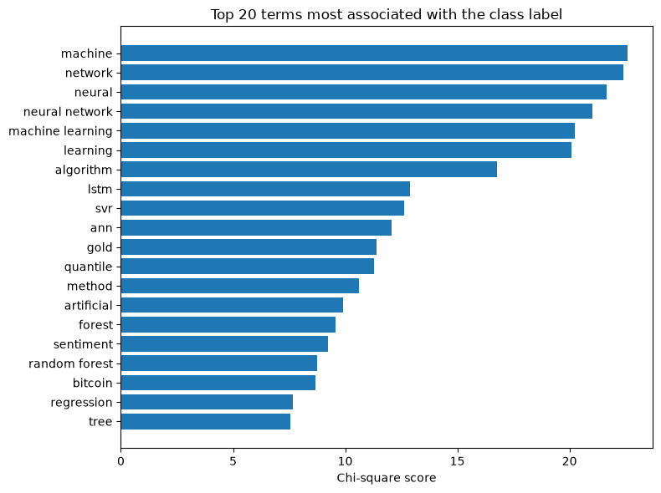
Figure 1: Top 20 terms by chi-square score

Baseline model
A Multinomial Naïve Bayes classifier with TF-IDF features was used as the baseline (EMC Education Services, 2015; Pedregosa et al., 2011), trained on a stratified 80/20 split (898 training, 225 test abstracts). It achieved 0.84 test accuracy, only slightly above the 0.79 obtained by always predicting “classical”. Its main weakness was the AI class: AI recall was 0.48 on the training set and 0.23 on the test set, with only 11 of 47 AI abstracts identified (Figure 2). Five-fold cross-validation gave a mean macro F1 of 0.62, close to the test score of 0.64, showing the results are stable. The model is biased towards the majority, because Naïve Bayes favours the more frequent class and both classes share most of their vocabulary.
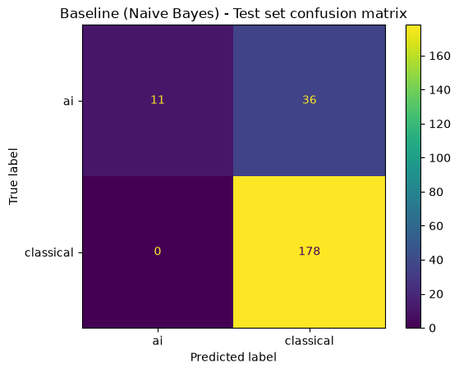
Figure 2: Baseline confusion matrix (test set)

Question 2

Model comparison
Four model were trained with the same TF-IDF features as the baseline: Logistic Regression, Linear SVM, Complement Naïve Bayes and Random Forest. Class weighting was used where supported because of the class imbalance. All four clearly outperformed the baseline, with test macro F1 rising from 0.64 to between 0.83 and 0.88, and AI recall from 0.23 to as high as 0.79 (Figure 3). Random Forest performed best on both the test set (macro F1 0.883) and cross-validation (0.849), although its perfect training score shows some overfitting. The cross-validation ranking matched the test ranking, so the comparison is reliable.
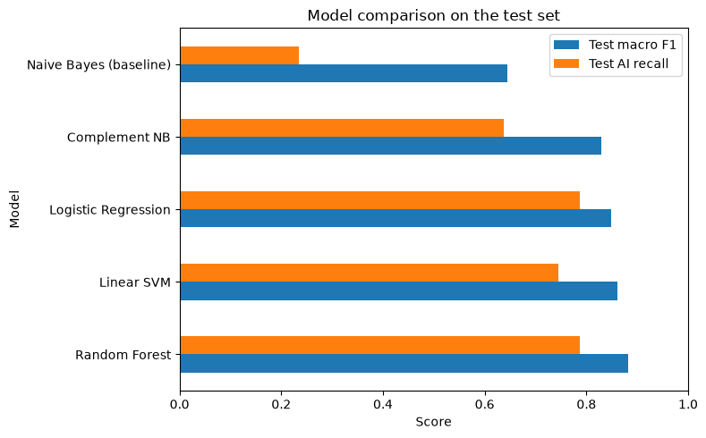
Figure 3: Model comparison on the test set

Performance enhancement: class weighting
Since the data is 79% classical and 21% AI, class weighting was chosen as the enhancement. It makes errors on the smaller AI class count more during training. Its effect was tested by training each model with and without it (Figure 4). Logistic Regression improved most (AI recall 0.21 to 0.79), and Random Forest also improved clearly (AI recall 0.55 to 0.79, test macro F1 0.83 to 0.88). Linear SVM gained AI recall but its macro F1 dipped slightly, as SVMs depend less on class frequencies. Hyperparameter tuning, threshold adjustment and a voting ensemble were also tested but gave no meaningful further improvement. The balanced Random Forest was therefore selected for deployment.
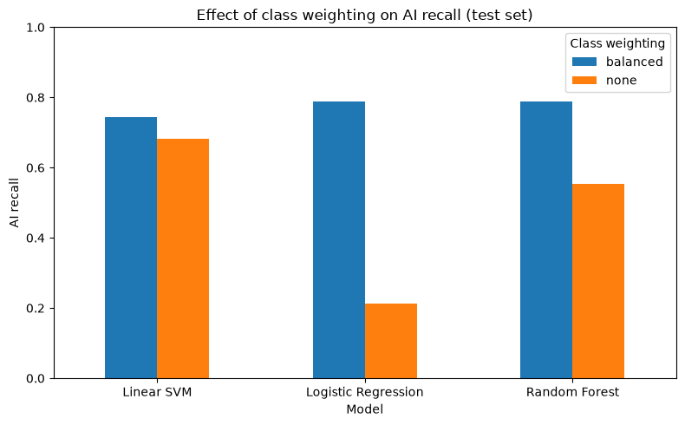
Figure 4: Effect of class weighting on AI recall

Deployment
The balanced Random Forest and its TF-IDF vectoriser were saved as one pipeline and deployed in a Streamlit web app matching the layout in the brief. The app applies the same cleaning function used in training before making a prediction. It correctly classified an unseen AI abstract and a classical economics abstract (Figures 5 and 6). Instruction for running the app are in the deployment folder’s README in the GitHub repository.
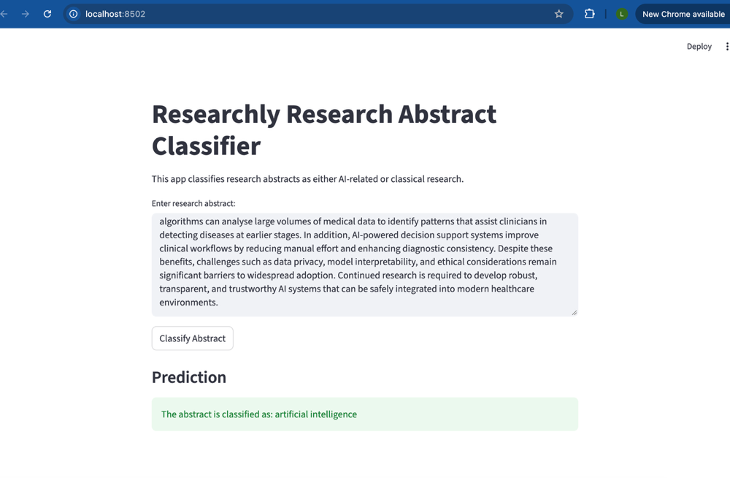
Figure 5: App classifying an AI abstract

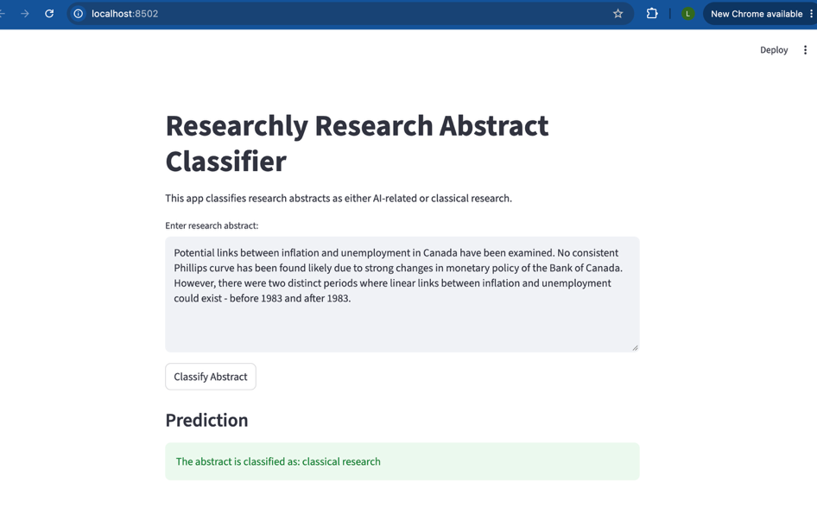
Figure 6: App classifying a classical abstract

Question 3

Building the dataframe
The five research article were read into a dataframe containing each article’s ID, file name, title and full content. Although the brief describes the corpus as AI research, all five articles are about research methodology: mixed methods research, researcher reflexivity, developmental research, Cronbach’s alpha and triangulation.

Preprocessing
The articles were extracted from PDFs and contained noise such as words split across lines, in-text citations, page headers, footnote numbers and repeated passages. These were removed with targeted regular expressions, and duplicate sentences were removed, which halved article 1 (5,602 to 2,624 words) because its text appeared twice. Two versions of the text were kept: a lightly cleaned version with full sentences for summarisation, and a fully preprocessed version for topic modelling. For the latter, spaCy was used to lowercase, remove stopwords and lemmatise the text (Cuantam Technologies, 2023; Honnibal et al., 2020), keeping only nouns, verbs, adjectives and adverbs.

Summary of article 1
Frequency-based extractive summarisation was used: each sentence was scored by the average frequency of its meaningful words, and the five highest-scoring sentences formed the summary (Figure 7). This reduced the article from 2,624 to 111 words (4.2%). The summary captures the main argument, that mixed methods research is a third research paradigm that bridges quantitative and qualitative research. However, it contains some repetition and leaves out the role of pragmatism, since frequency scoring favours sentences containing the most common words.
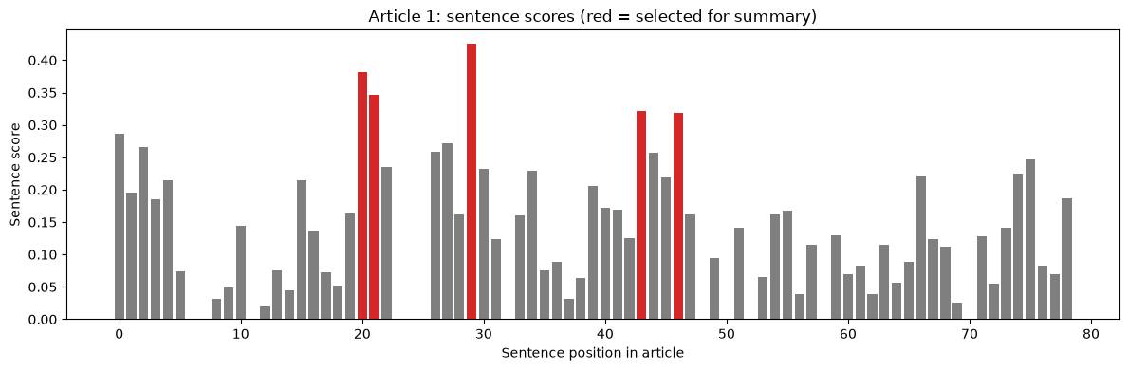
Figure 7: Article 1 sentence scores (red = selected)

Aggregate summary of articles 2-5
TextRank was used for the remaining articles. Sentences were connected in a graph by how similar their wording is, and ranked with the PageRank algorithm, so the most central sentences were selected (Figure 8). The three top sentences from each article were then combined into one aggregated summary covering reflexivity and researcher position, developmental research in instructional design, the use of Cronbach’s alpha as a reliability measure, and triangulation in qualitative research. Keywords, titles and page headers initially ranked highly because they overlap with many sentences, so they were filtered out first. Compared with the frequency method, TextRank selected more varied and representative sentences.
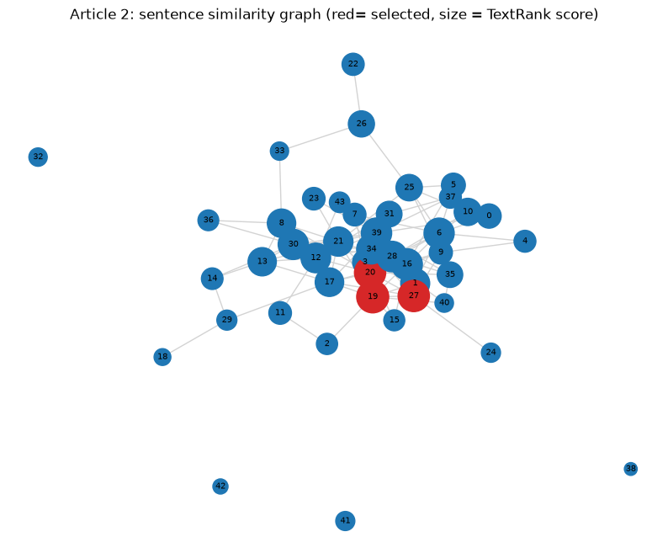
Figure 8: Article 2 sentence similarity graph (red = selected)

Question 4

LDA topic modelling
LDA (Blei, Ng and Jordan, 2003; EMC Education Services, 2015) needs many documents to find patterns, so each article was split into chunks of five sentences, giving 131 documents. Common two-word phrases (e.g. “cronbach_alpha”, “data_triangulation”) were joined into single tokens, and very rare and very common words were removed. Coherence scores were calculated for 2 to 10 topics (Figure 9). Three topics scored highest (0.534) but merged unrelated articles, so eight topics (0.485) were chosen because they gave distinct, interpretable theme. The main topics were developmental research, Cronbach’s alpha and measurement, reflexivity and researcher position, mixed methods and the paradigm debate, and triangulation, with three weaker background topics. The heatmap (Figure 10) shows each main topic links mostly to one article, while some topics connect articles, for example mixed methods and triangulation, which both concern combining methods. Overall, the corpus focuses on how to make research rigorous and trustworthy.
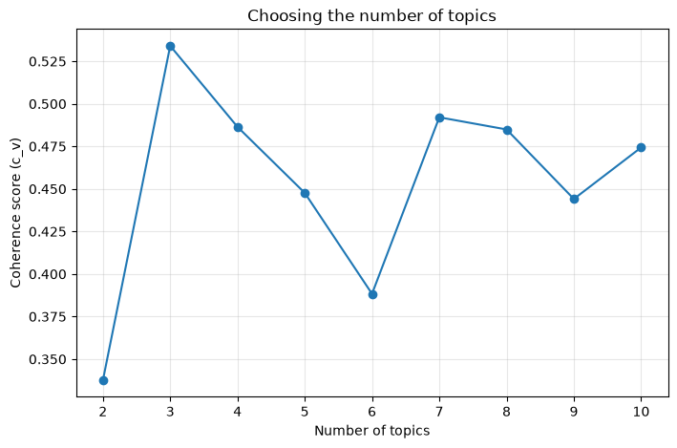
Figure 9: Coherence score by number of topics
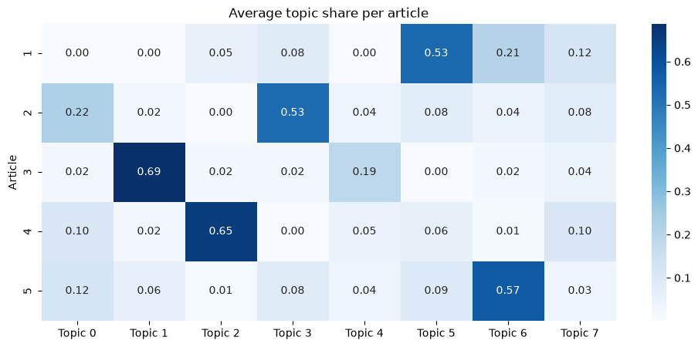
Figure 10: Average topic share per article

Intertopic distance map
pyLDAvis was used to create an interactive intertopic distance map (Figure 11), where circle size shows a topic’s share of the corpus and distance shows how different topics are. Note that pyLDAvis numbers topics from 1, so its topic n is genism topic n – 1. The qualitative methodology topics (reflexivity, triangulation and mixed methods) overlap in one cluster, while the Cronbach’s alpha topic stands far apart because of its statistical vocabulary. Developmental research forms its own separate region. The interactive version is in the GitHub repository’s outputs folder.
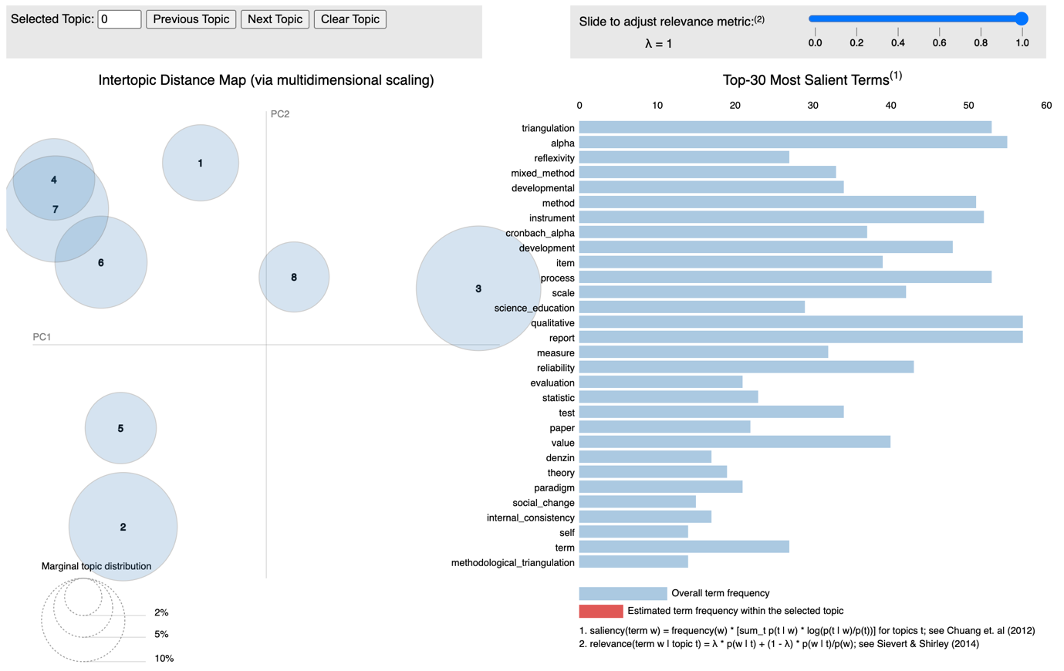
Figure 11: pyLDAvis intertopic distance map

GitHub repository
The GitHub repository contains the project documentation, the datasets, the notebooks for all four questions and a deployment folder with a README explaining how to run the web app: https://github.com/liampaulstevens-oss/ITNPA4-34--Project1--eduv13228736

References
Blei, D.M., Ng, A.Y. and Jordan, M.I. (2003) ‘Latent Dirichlet allocation’, Journal of Machine Learning Research, 3, pp. 993–1022.
Canchila, S., Meneses-Eraso, C., Casanoves-Boix, J., Cortés-Pellicer, P. and Castelló-Sirvent, F. (2024) ‘Natural language processing: an overview of models, transformers and applied practices’, Computer Science and Information Systems, 21(3), pp. 1097-1145. Available at: https://riunet.upv.es/server/api/NLP-Canchila (Accessed: 27 October 2026).
Cuantum Technologies (2023) Natural language processing with Python: building your own customer service chatbot. Independently published.
DeepLearning.ai (2023) A complete guide to natural language processing. Available at: https://www.deeplearning.ai/resources/natural-language-processing/ (Accessed: 27 October 2026).
EMC Education Services (2015) Data science and big data analytics: discovering, analyzing, visualizing and presenting data. Indianapolis: John Wiley & Sons.
Honnibal, M., Montani, I., Van Landeghem, S. and Boyd, A. (2020) spaCy: industrial-strength natural language processing in Python. Zenodo. doi:10.5281/zenodo.1212303.
Pedregosa, F. et al. (2011) ‘Scikit-learn: machine learning in Python’, Journal of Machine Learning Research, 12, pp. 2825–2830.

